CHANGING DISPLAY SETTINGS ON LAPTOPS
[Type the sender company address] [Type the sender phone number] [Type the sender e-mail address]
CHANGING DISPLAY SETTINGS ON LAPTOPS

Summary:
You can change your desktop in to point to different monitors by using the video drivers utility. This is the same as hitting Fn+F8 but you will be able to see exactly what is going on.
Directions:
Right click on your desktop
Choose the choice NVIDIA Control Panel (the first time you do this you will need to choose Advanced mode)
On the Left task section choose Set up multiple displays.
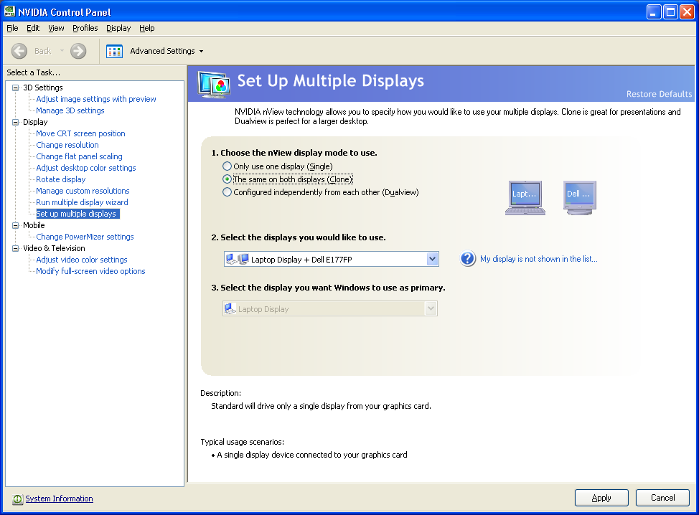
Choose the setting you want. (If you are using a projector you will want the Clone setting).
Make sure the two devices are listed.
Click Apply. After you click Apply click Yes if you want to keep the changes otherwise it will revert back.

